SERIALIZATION:

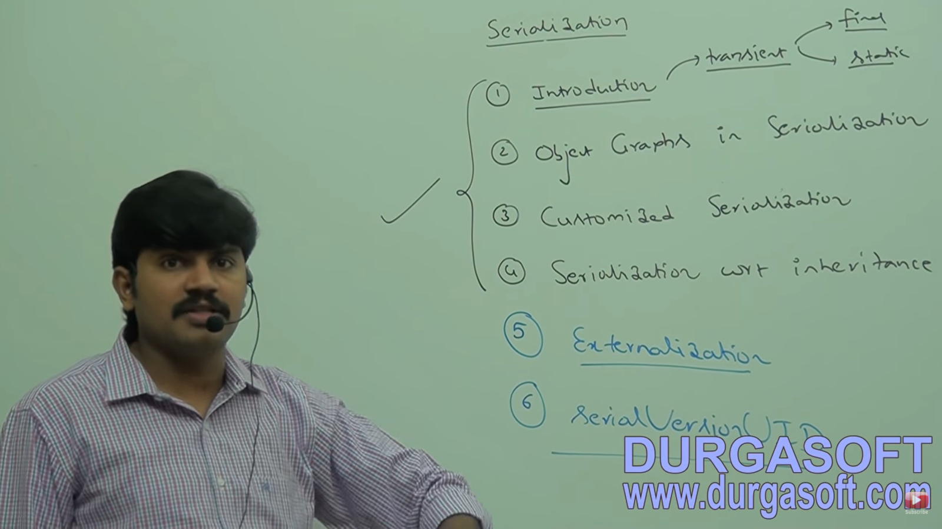

The process of saving state of an object to a file is called serialization and reading is called De-serailaization. (This is not perfect definition)

The process of converting object from java supported form to File or Network Supported form is called Serialization.

The process of converting object from File or Network Supported form to java supported form is called Serialization.

STREAMS TO IMPLEMENT SERIALIZATION:

By using FileOutputStream and ObjectOutputStream, we can implement SERIALIZATION.

ObjectOutputStream takes object and convert it into Binary Data.

FileOutputStream writes this binary data to the File.

DESERIALIZATON: ObjectInputStream and FileInputStream needed.

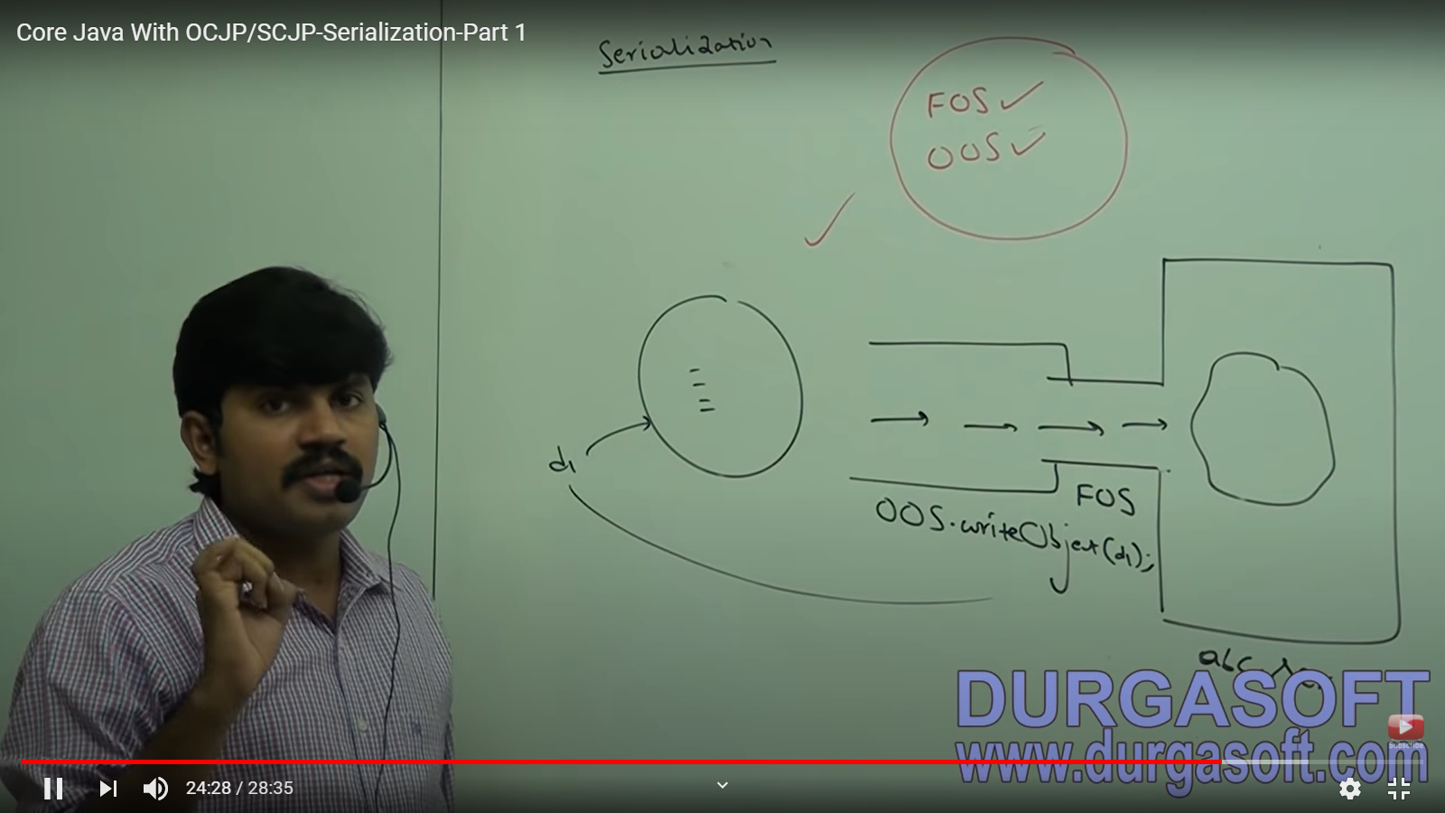

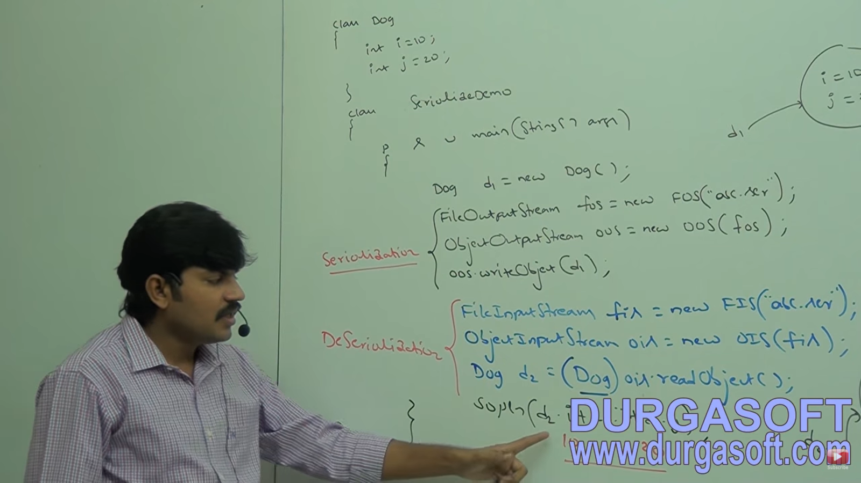

Here Dog class should implement Serializable. If it is not implemented, the code will compile but we will get a Run time Exception: **NotSerializableException**. There is no problem at compile time.

We do not have to take care of whether the file is inside the working directory or not. If it is not there, the line will create one for us.

SERIALIZABLE INTERFACE:

Present in java.io package

It is a MAPPER INTERFACE.

An object is considered serializable if and only if it implements Serializable interface.

TRANSIENT KEYWORD: NOT TO SERIALIZE

Applicable only for variable

If any time of serialization if we do not want to save the value of a particular variable to meet security constraints, we mark it as transient. This variable marked with transient, JVM will not store the original value, but will take its default value and store it.

STATIC AND TRANSIENT

Since static variable does not belong to an object but belongs to a class, it will not participate in Serialization. And hence, transient keyword used before static variables is of no use.

Note: If there are two variables (one normal variable and other static) then static variable is created first at the time of class instantiation loading only.

FINAL AND TRANSIENT:

Every final variable will be replaced by the value at compile time only.

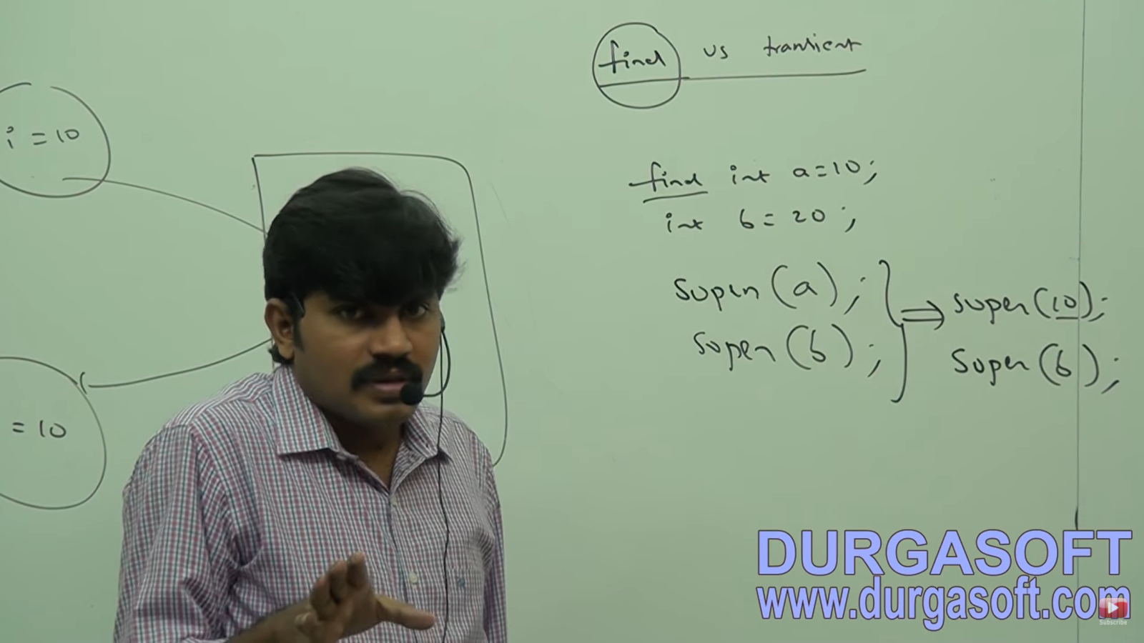

So, whether we serialize final variable or not, there will be no difference or impact.

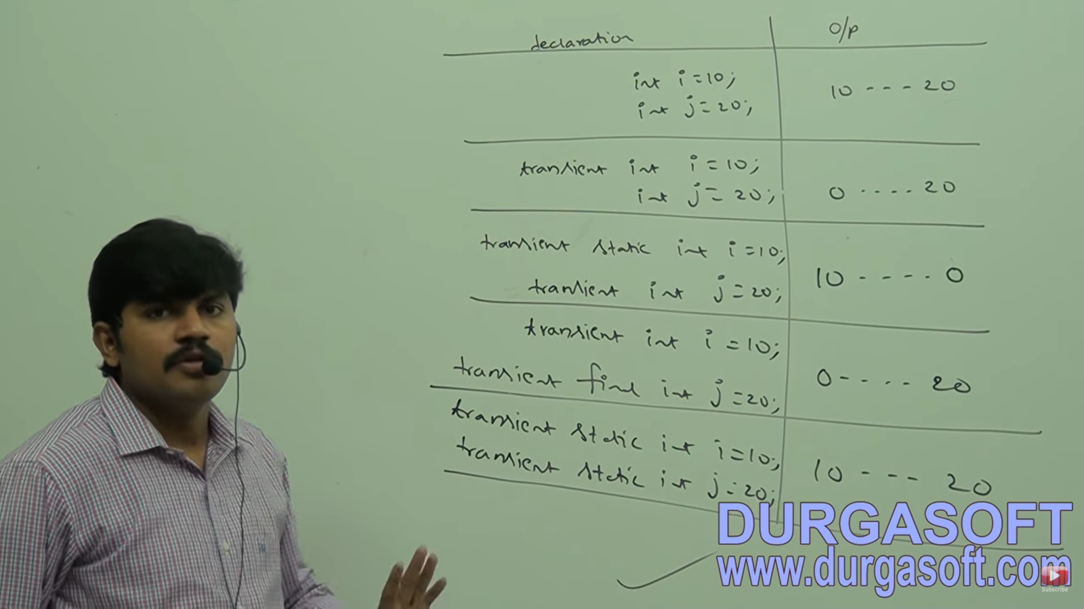

CAN WE SERIALIZED MULTIPLE OBJECTS???

We can serialize any number of objects. But rule is the order in which an object is serialized, the same order the objects should be deserialized. Or else we will get **CLASSCASTEXCEPTION**.

IF YOU DO NOT KNOW THE ORDER OF OBJECTS IN SERIALIZATON??

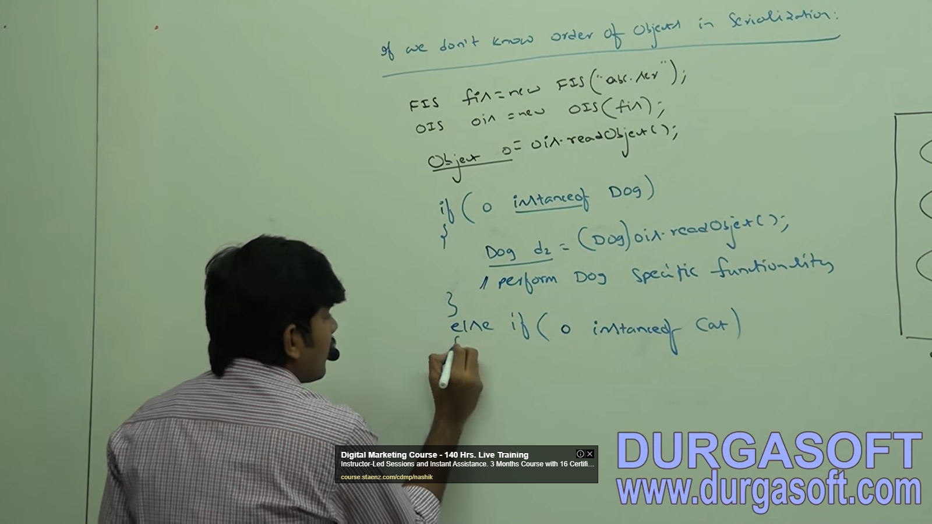

CUSTOMIZED SERIALIZATION (To recover loss of info due to transient keyword)

In default Serialization, because of transient, there may be a loss of information i.e.

int will be replaced by 0 and String as null i.e. the default values. So, we need Customized Serialization to recover the loss of information.

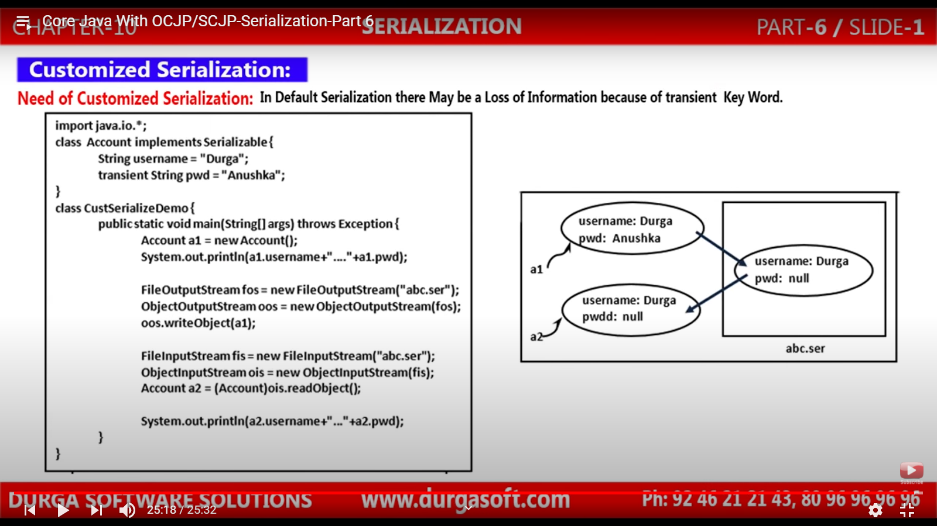

At sender and receiver side we have to do some extra work so that we can recover the information which is lost. This extra work is nothing but customized serialization.

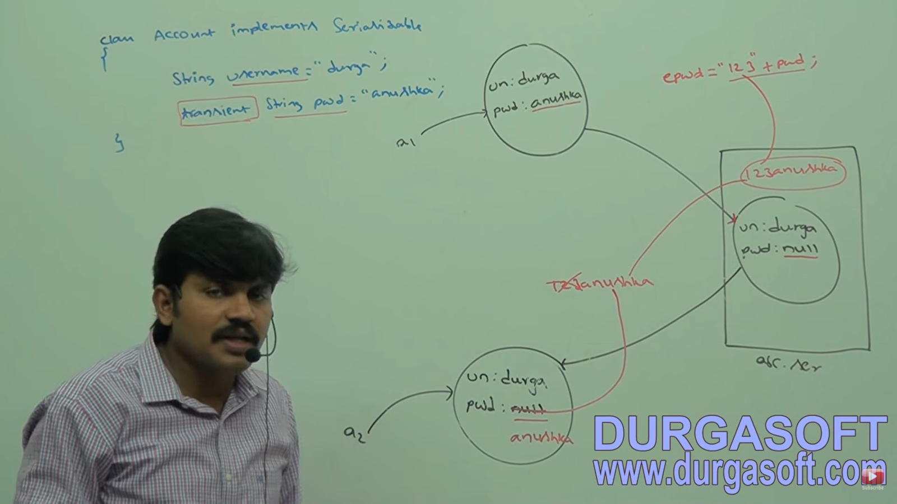

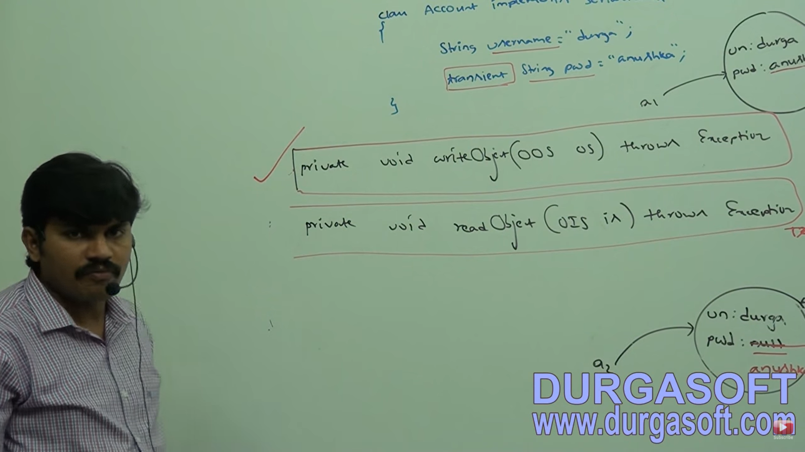

These two objects will be invoked automatically by the JVM at the time of Serialization. Hence, they are callback methods. At time of serialization what extra work you are doing, write it inside the writeObject method and at time of de- serialization what extra work you are doing, write it inside the readObject

These methods should have the same syntax i.e. private void ...

These methods need to be placed inside the Class whose object is being serialized.

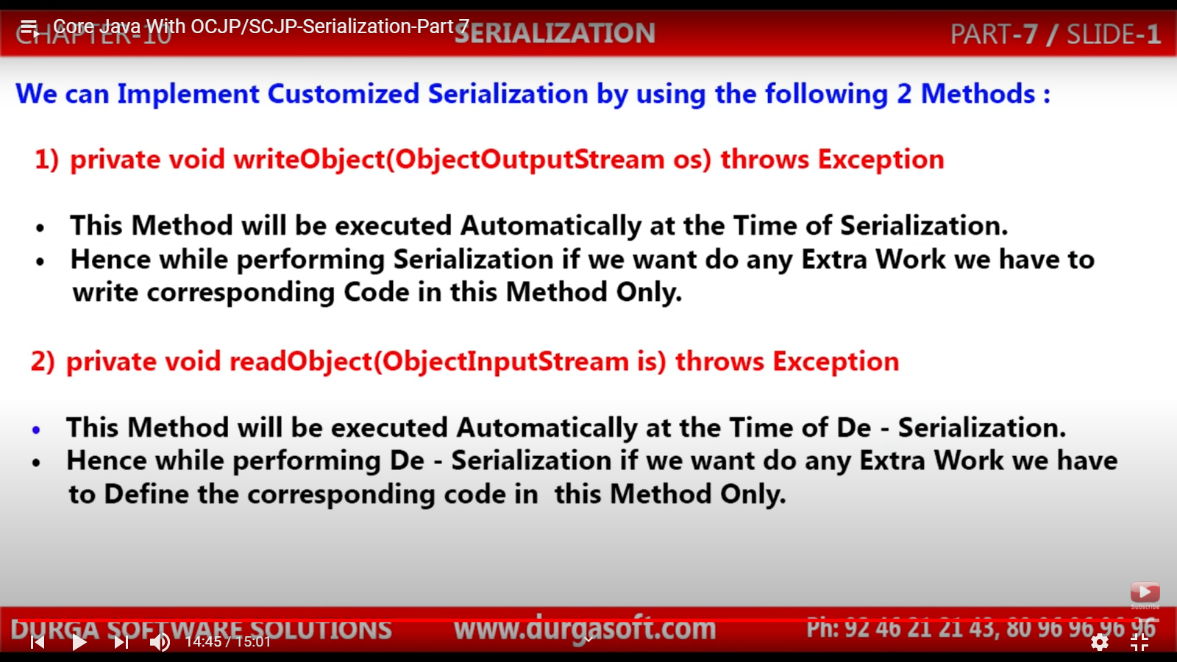

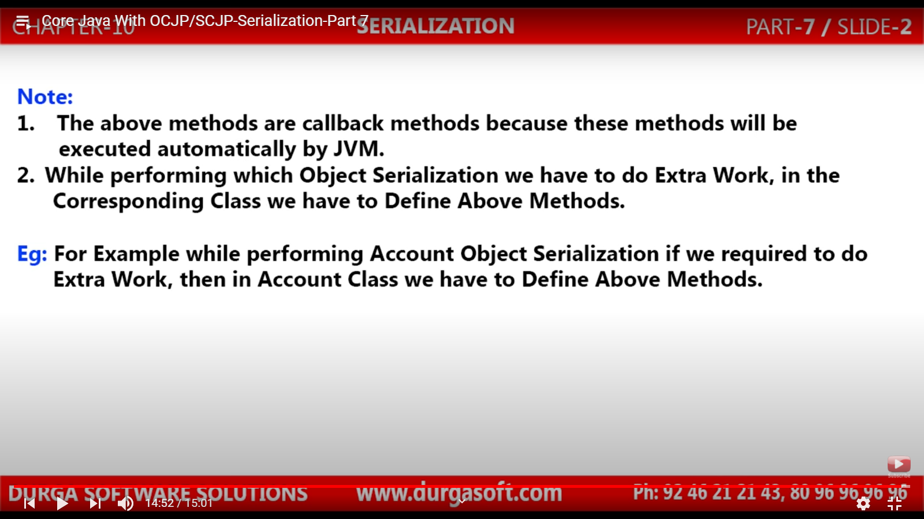

JVM will check the Class whose object is getting serialized and if it finds a writeObject or readObject methods, then it will understand that Customized Serialization is taking place. If it does not find the methods inside the class, then the writeObject called will proceed normally.

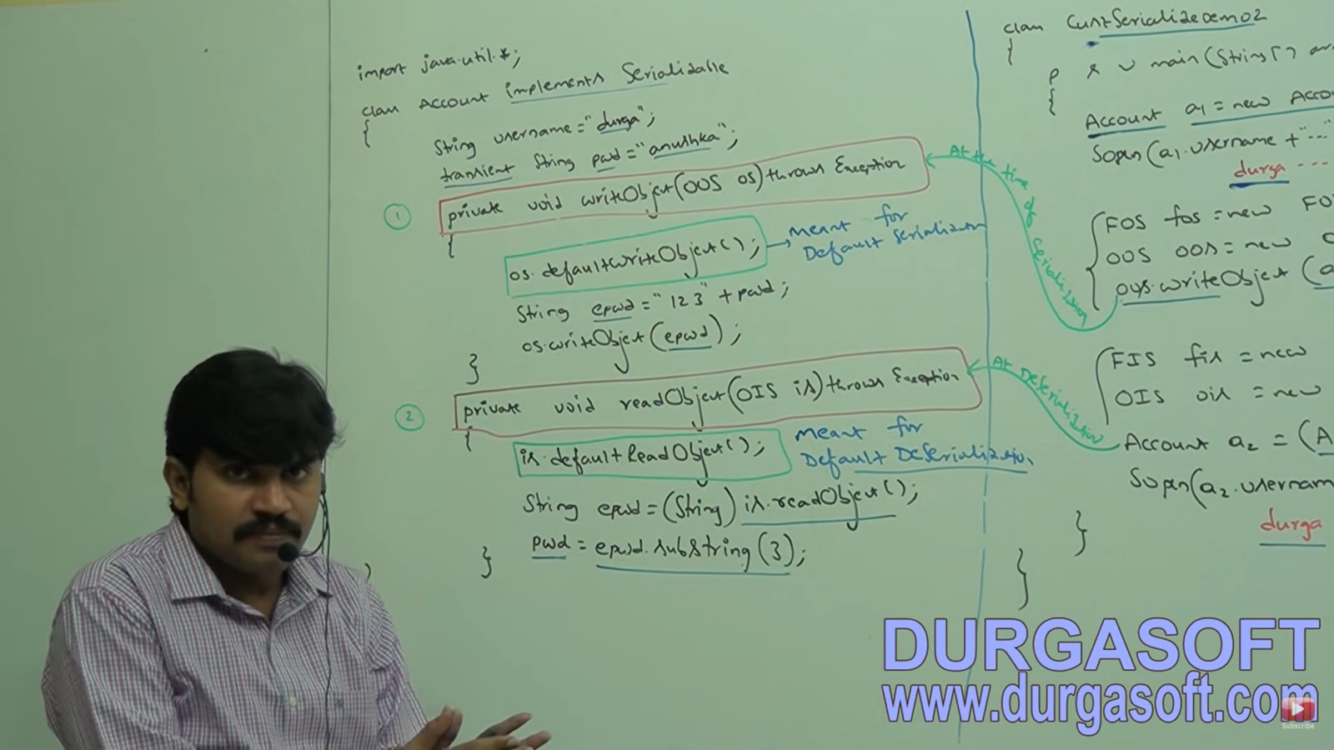

So, if the above two methods PRESENT then => CUSTOMIZED SERIALIZATION

If the above two methods ABSENT then => DEFAULT SERIALIZATION

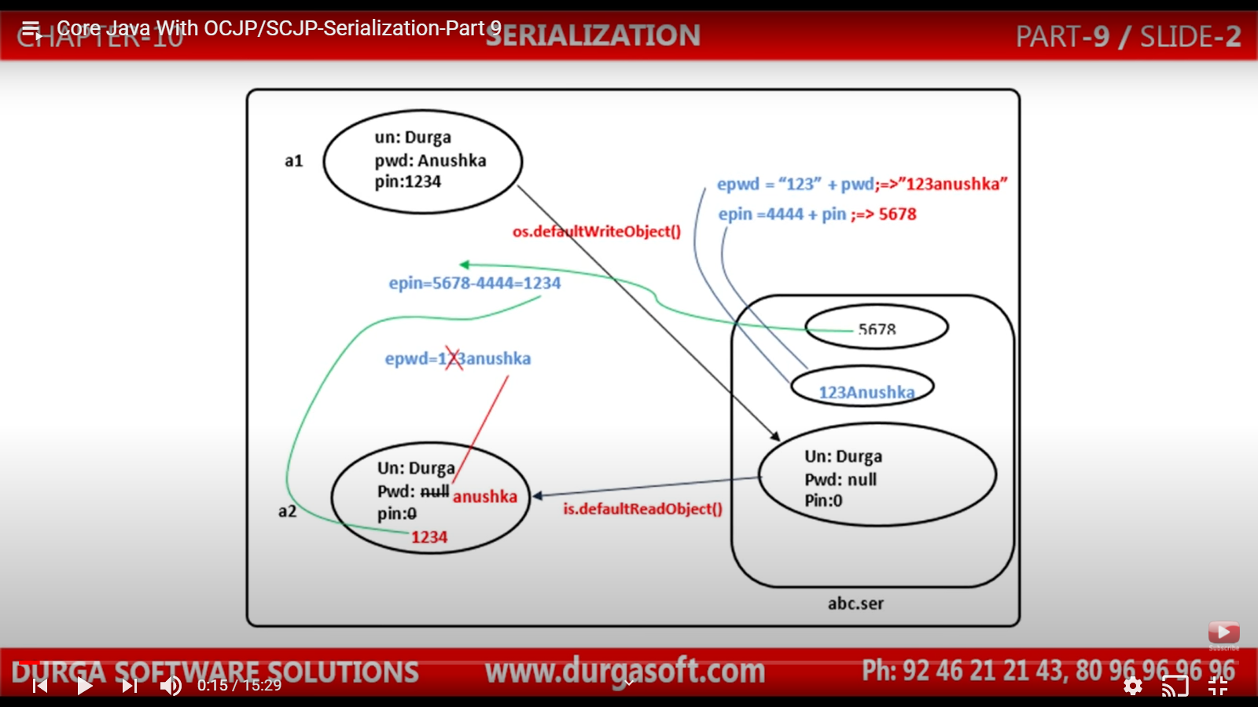

With two variables

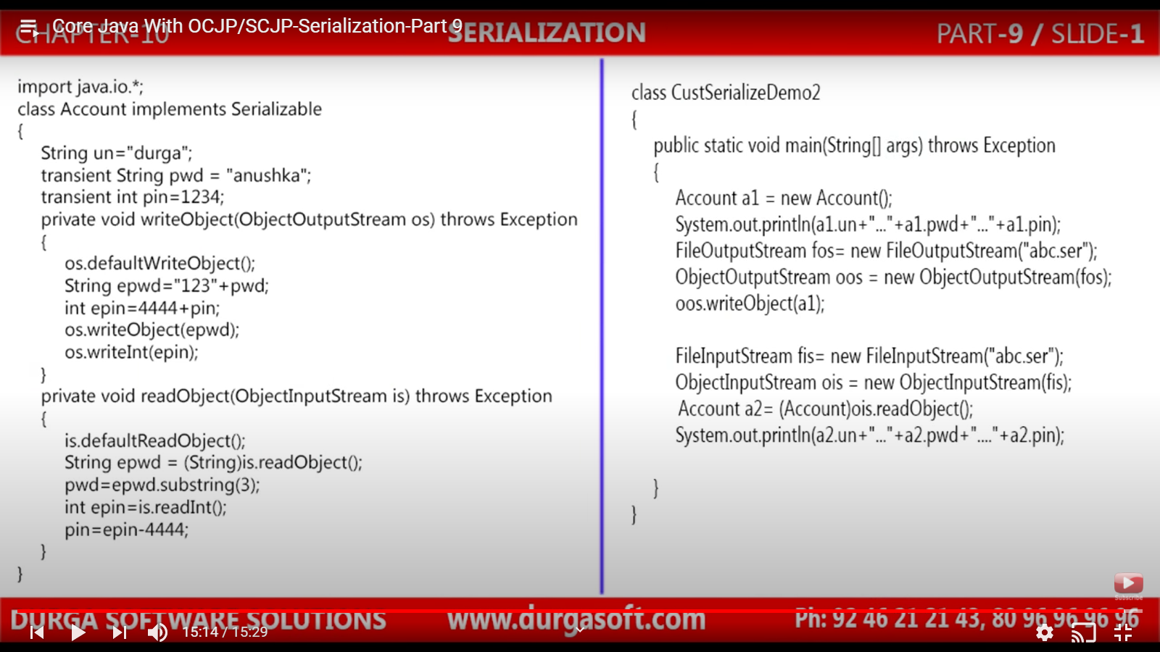

SERIALIZATION WITH RESPECT TO INHERITANCE:

CASE 1: PARENT IMPLEMENTS BUT CHILD DOES NOT

In this case, Serializable will be inherited by the child and the code compiles happily. Serializable nature is inheritable from Parent to Child. So, if PARENT is serializable, by default, every CHILD is serializable

NOTE:

1. Object is non-serializable. Since if it was serializable then every class must have been serializable
2. GENERIC SERVLET: This implements serializable. So, all servlet class in java are serializable.

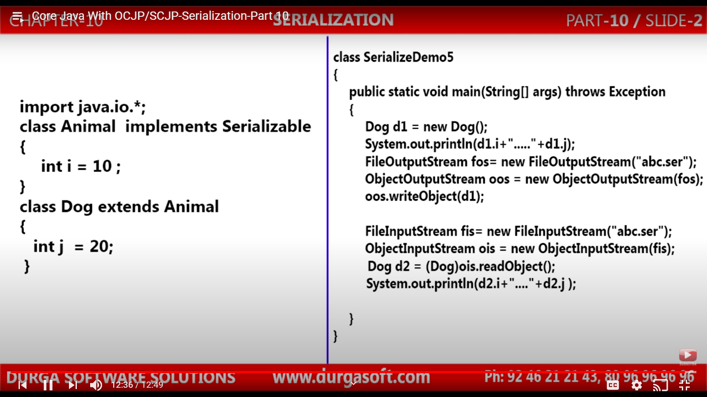

CASE 2: CHILD IMPLEMENTS BUT PARENT DOES NOT (4 conclusions)

1. To serialize child class object parent class need not be serializable.
2. 2) At the time of serialization, JVM ignore the original values (Which are modified inside the class) coming from non- serializable parent and assigns the default value to it.
3. During the time of de- serializable, JVM will check if there is any parent which is non-serializable or not. If it is then JVM will execute INSTANCE CONTROL FLOW and share its instance variable value to the current object.
4. In INSTANCE CONTROL FLOW, JVM will call no argument constructor. If it is not present, then we will get **INVALIDCLASSEXCEPTION**.

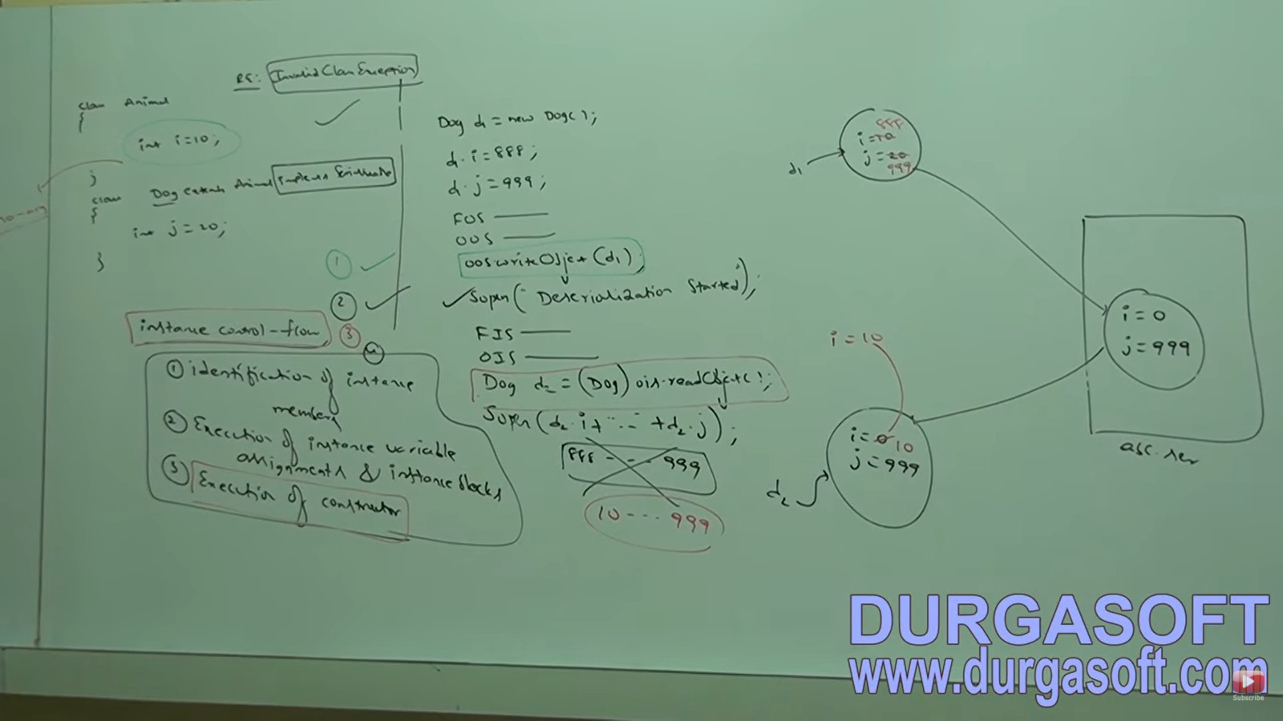



EXTERNALIZATION: (Using Externalizable Interface) 🡪 Came in 1.1v only

In serialization, if the class contains large number of properties, to make the object serializable, only 3 steps needed. i.e. it is very easy to serialize an object.

1. Here, everything is taken care by the JVM and programmer has very less task to do or has less control.

If there are large no of properties say 100 or 1000, then all the properties will be serialized. Even if we want to deal with only some properties, all properties will be saved. If we use transient or other things, the variables may have default values, but the variable might be present assigned with some values.

1. So, in serialization it is always possible to saved total object and not part of an object which may create performance problems.

To overcome these problems, we use EXTERNALIZATION.

Adv: Everything is taken care by programmer, JVM does not have any control.

If we want to store only some properties, we can do so and not save entire object. So, here performance is high.

So, if we want to save entire object, use SERIALIZATION and if we want to save partial object, use EXTERNALIZATION.

There are two methods in Externalizable interface.

1. writeExternal
   1. It is executed automatically during SERIALIZATION.
   2. Here, we have to write the code to save the required properties to the file.
2. ReadExternal
   1. It is executed automatically during DE-SERIALIZATION.
   2. Here, we have to write the code to read the required properties from the file.

It is child interface of SERIALIZABLE only. EXTERNALIZATION is less famous since many people go for Serialization since there JVM has to do all the task.

We know in Serialization, entire object in present in file and during de-serialization, the entire object is read or fetched. But in Externalization, since we do not have entire object and only have some properties of an object, JVM will automatically create an object of the class and call the readExternal method on this object. Now this method reads that properties and assign to current object.

JVM will always call public no-argument constructor to create this object. So, if the constructor is not present, we will get RE: **INVALIDCLASSEXCEPTION.** Since in serialization, total object is present in file, we do not need to have a non-argument constructor.

**Doubts: If multiple strings present?????????????????????**

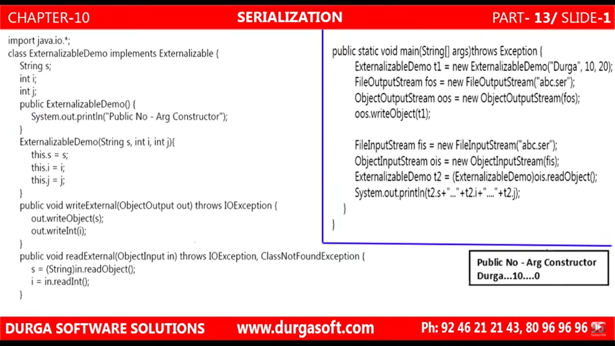

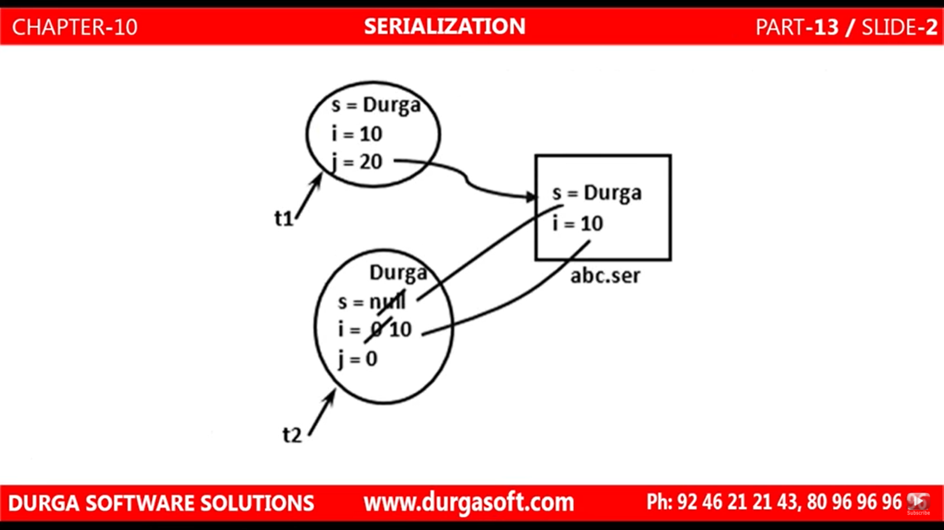



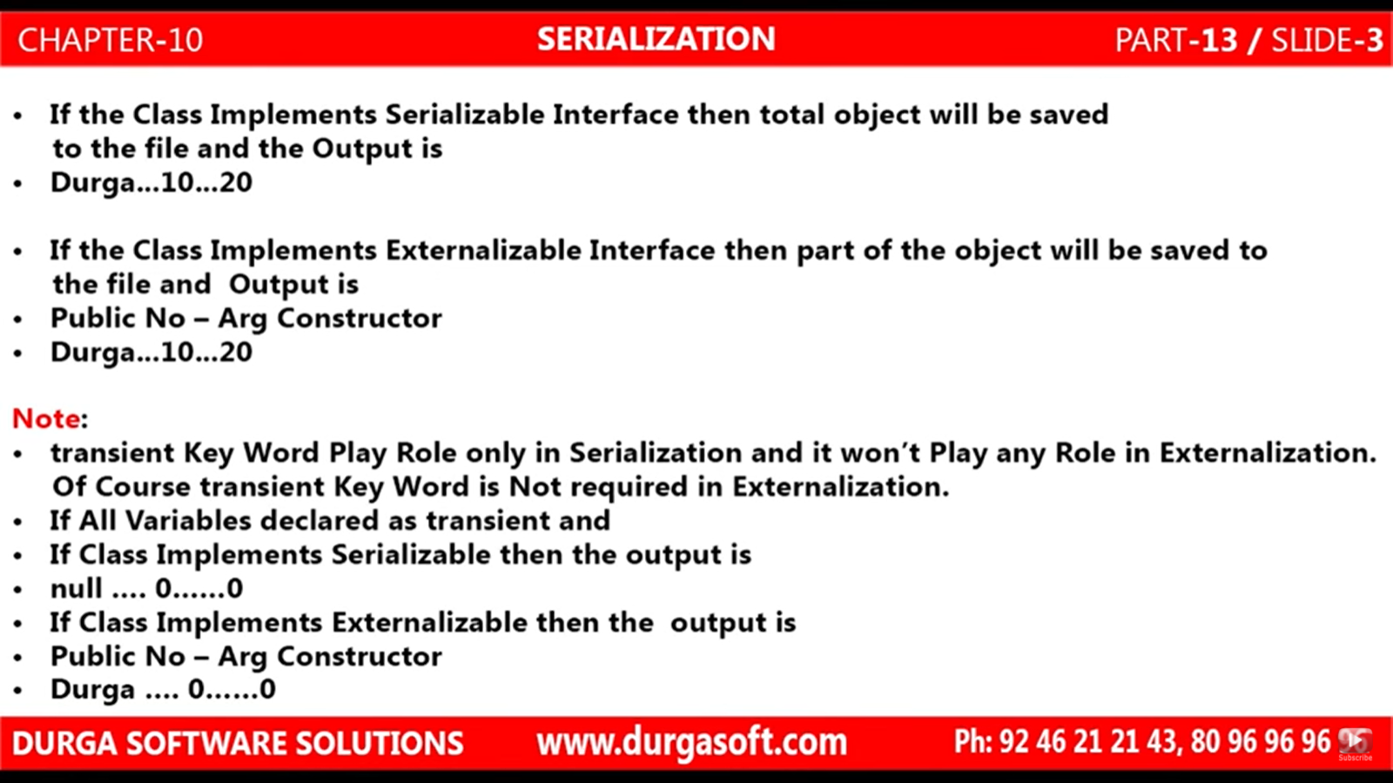

Transient is not needed in EXTERNALOZATION since programmer is saving data to file. Here if he does not want to write data, he has a choice not to write it. But in Serialization, since only JVM can write data to a file, we had transient there.

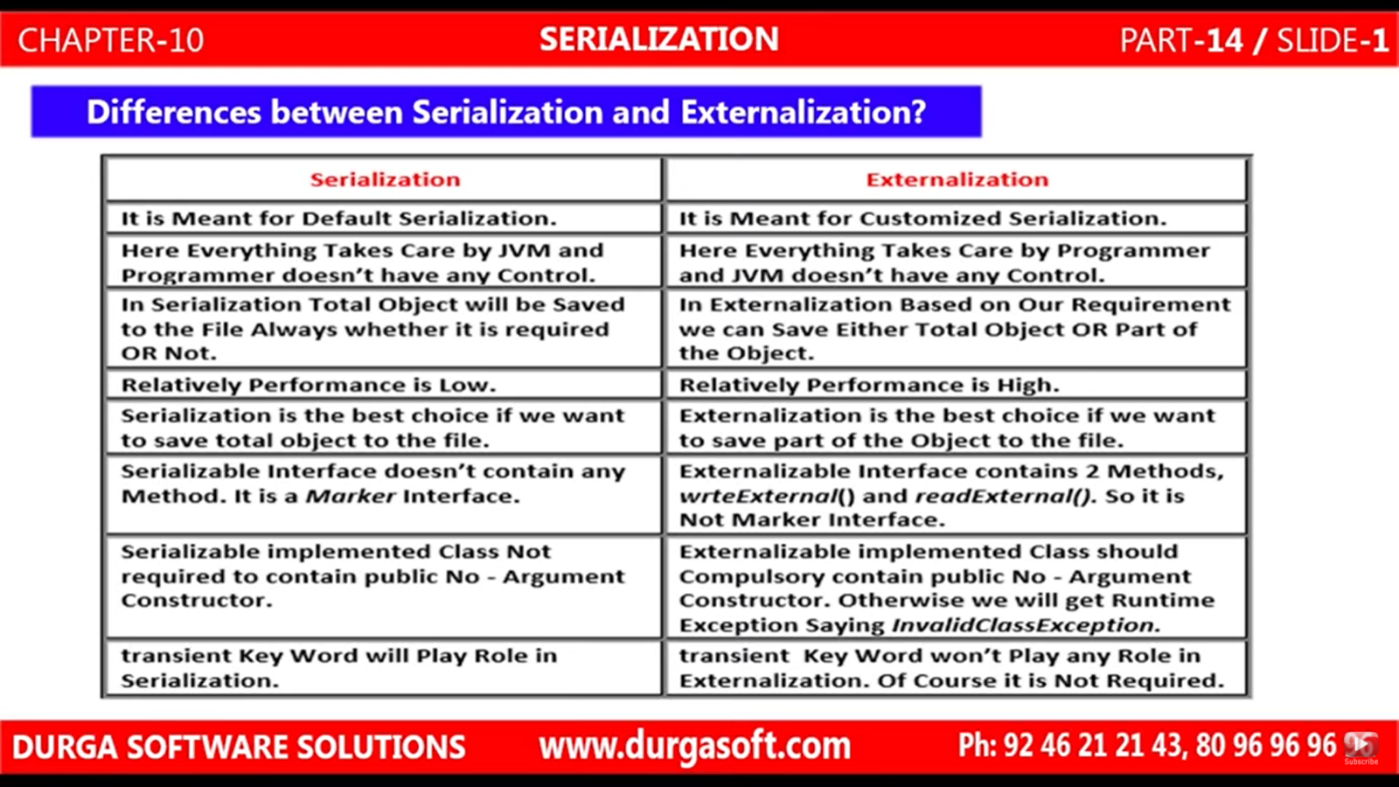

SerialVersionUID: (using this we are not letting JVM to create an Unique ID).

SOME FACTS ABOUT SERIALIZATION & DE- SERIALIZATION:

1. Sender and Receiver need not be the same.
2. Sender and Receiver need not be from the same location.
3. Sender and Receiver need not to use the same machine. (Say one is LINUX ans other Windows).

Now, at Sender side SERIALIZATION code will be executred and at receiver side DE- SERIALIZATION code will be executed and we need to have a .class file at both the ends or sides for this.

If at the receiver side, .class file is present, then we can create an object normally using a new keyword, then why to use the data from file. This is because though we can create an object, we cannot have the STATE of the object stored in that object.

Now, during SERIALIZATION, with every object the sender-side JVM will save an UNIQUE IDENTIFIER. **This unique identifier is generated by JVM based on .class file**. i.e. based on .class file, then sender-side JVM will create a unique ID associated with every object. AT receiver end, based on the local .class file, the JVM will create an ID and if both the IDs match, then DE- SERIALIZATION will take place else, we will get RE: **INVALIDCLASSEXCEPTION.**

THIS UNIQUE ID IS NOTHING BUT SerialVersionUID.

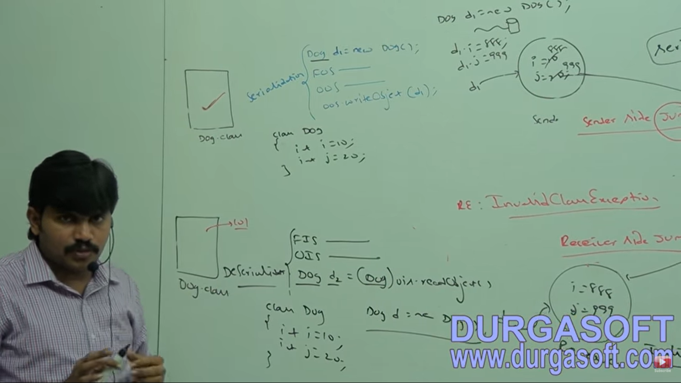

PROBLEMS OF DEPENDING ON DEFAULT SERIALVERSIONUID GENERATED BY JVM:

1. SENDER using LINUX with 1.6v JVM and Receiver using Windows with 1.8v JVM. Then different UIDs may be generated because of different JVM and diff Vendor. So, we may get

RE: **INVALIDCLASSEXCEPTION.**

1. Now, JVM and OS i.e. vendor is same but .class file is modified at one place.

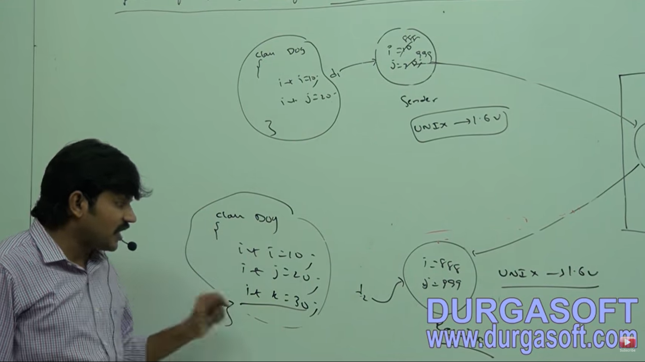

1. To generate SerialVersionUID, JVM internally may use Complex Algorithms which may cause performance problems.

If there is no change in JVM version or .class file Version, then no problem. Serialization will take place successfully.

Now if after Serialization, even if sender and receiver is at one place and the receiver modifies the .class file by adding a new variable to the class, then ID generated will not be same even though JVM is same.

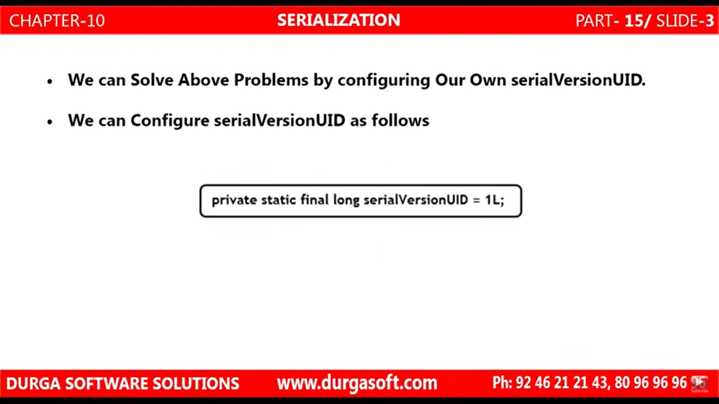

[**https://www.youtube.com/watch?v=7cGKyPxF1PA&list=PLd3UqWTnYXOl0LRB42B9uTIT3NEDhjhF2&index=16**](https://www.youtube.com/watch?v=7cGKyPxF1PA&list=PLd3UqWTnYXOl0LRB42B9uTIT3NEDhjhF2&index=16)

**FILE HANDLING:**

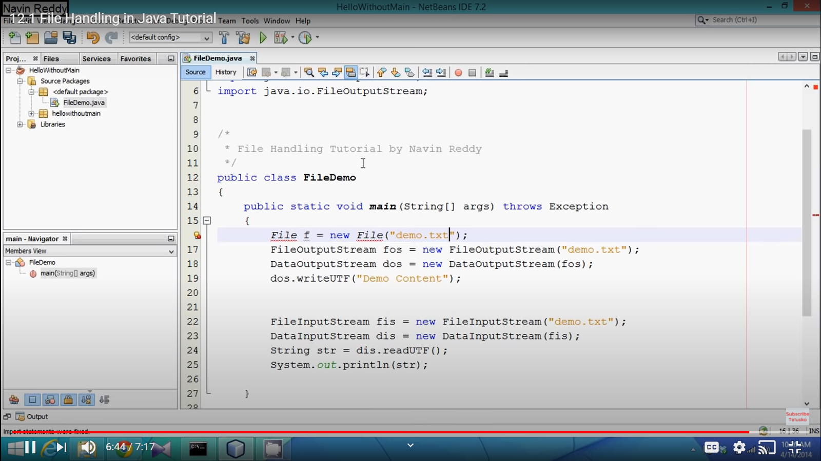

WHY FILES than Database:

Persistent Storage (Files is stored on a Hard disk. After restart of a PC/ system, it will be present there)

Need to store small Amount of data

Data does not change frequently.

When we do not have users accessing the data concurrently.

In DBMS (software which manages the data), we need to install software and also need DBA (Database Administrator) and we need to install the updates for that even for a small amount of data. So, we go for files when above conditions are met.

Say your system runs on different domains:

Windows 10 and Main Frame (Will come to know in OS). then there is no API to send data from one domain to other. So, we need files here. We do Secure File Transfer (SFTP).

Before using a file, we need an object for that file. So, it can have multiple methods and attributes on it.

We have File Class provide by Jav in java.io.*

We have 3 constructors in File class.

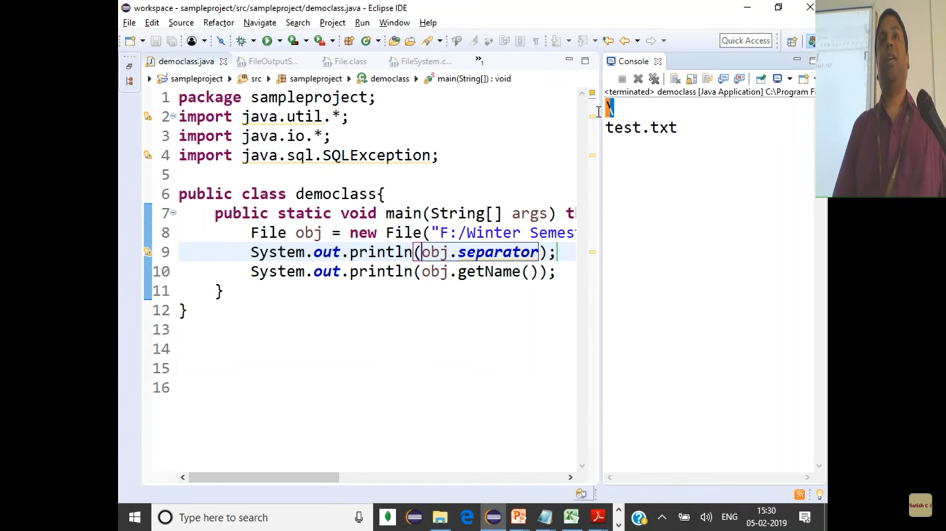

An abstract path is independent of the machine. The system is going to take it and convert into machine specific par\th. We can see after converting it to system path, the delimiter is ‘**\**’.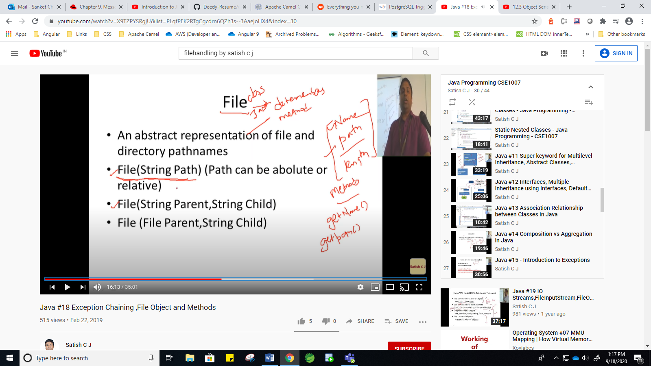

Parent is the directory path and child is the file name.

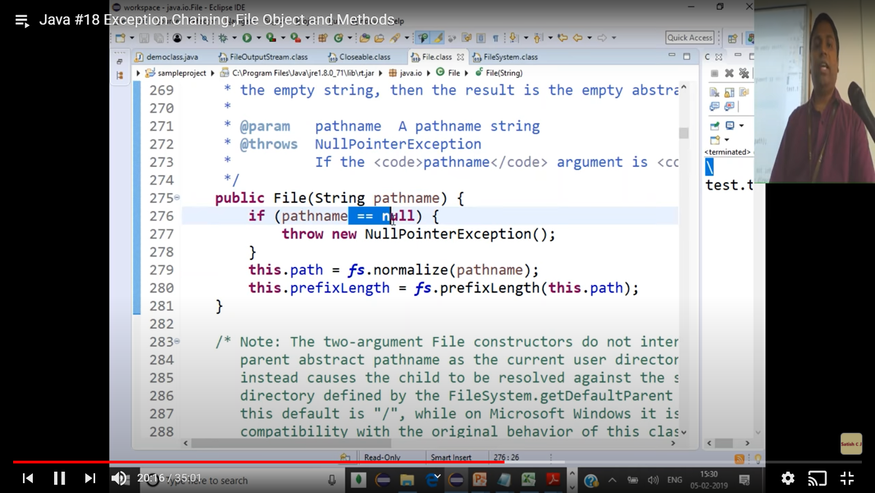

Java along with OS, converts the path to machine specific through normalize().

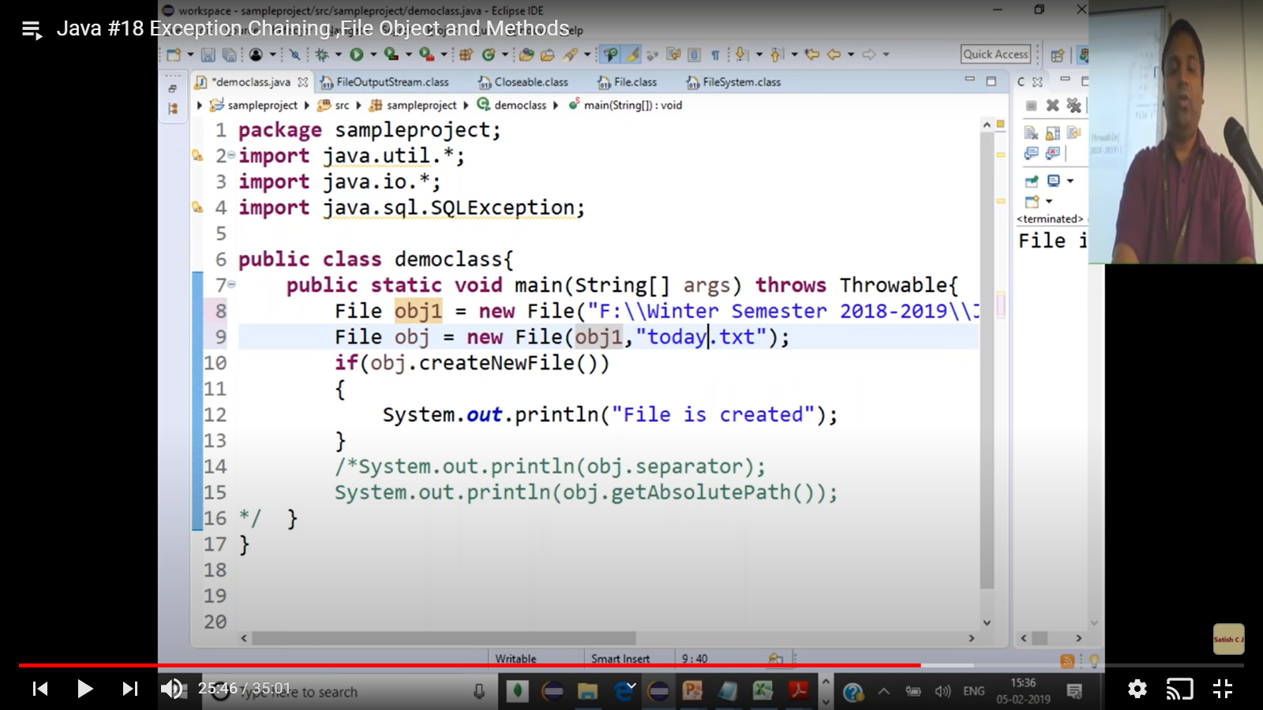

Third case

Obj.createNewFile will create a file if it is not present in the directory.

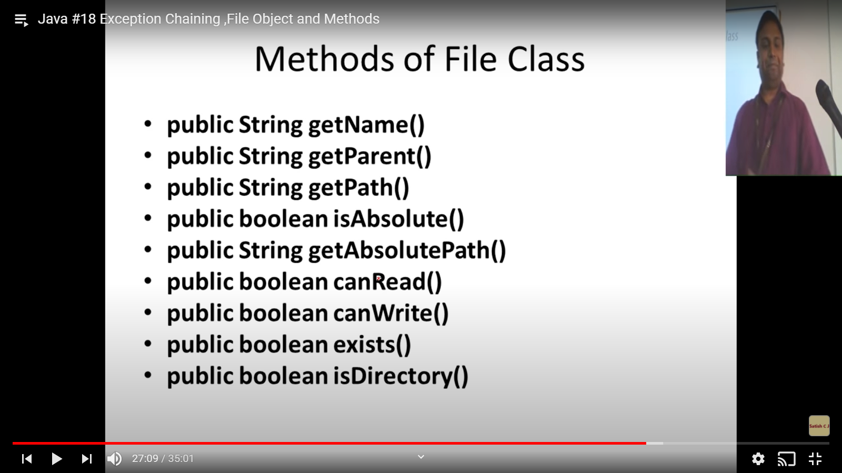

Therse methods are used to check if we can read or write or do other things. Bcause ,if it is not donw. It will throuw IO Exceptions.

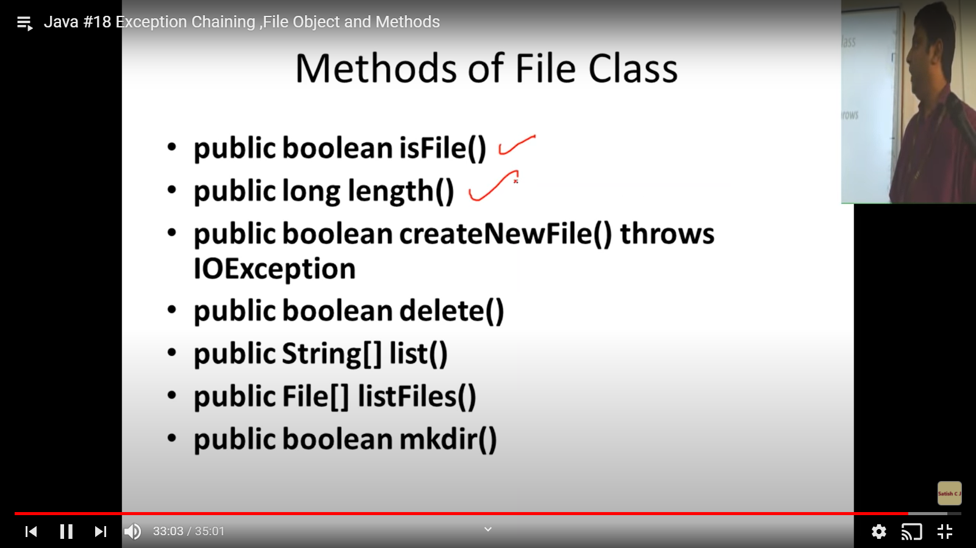

The main difference between them is that

* The **list ()** method returns the names of all files in the given directory in the form of a **String array**.
* The **ListFiles ()** method returns the objects (File) of the files in the given directory, in the form of an array of **type File**.

<https://www.tutorialspoint.com/difference-between-the-list-and-listfiles-methods-in-java#:~:text=The%20list()%20method%20returns,an%20array%20of%20type%20File>.

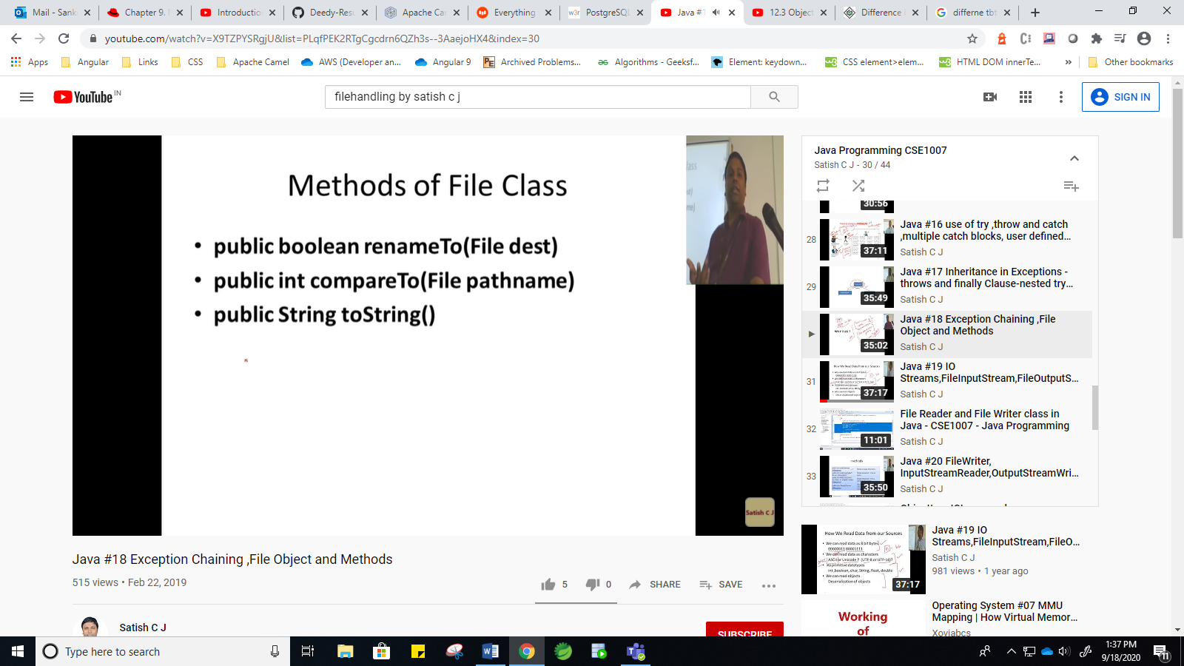

IOSTEAMS:

Stream: Sequence of dta oe bytels

Iotream: read data from an input souce and Write to output source

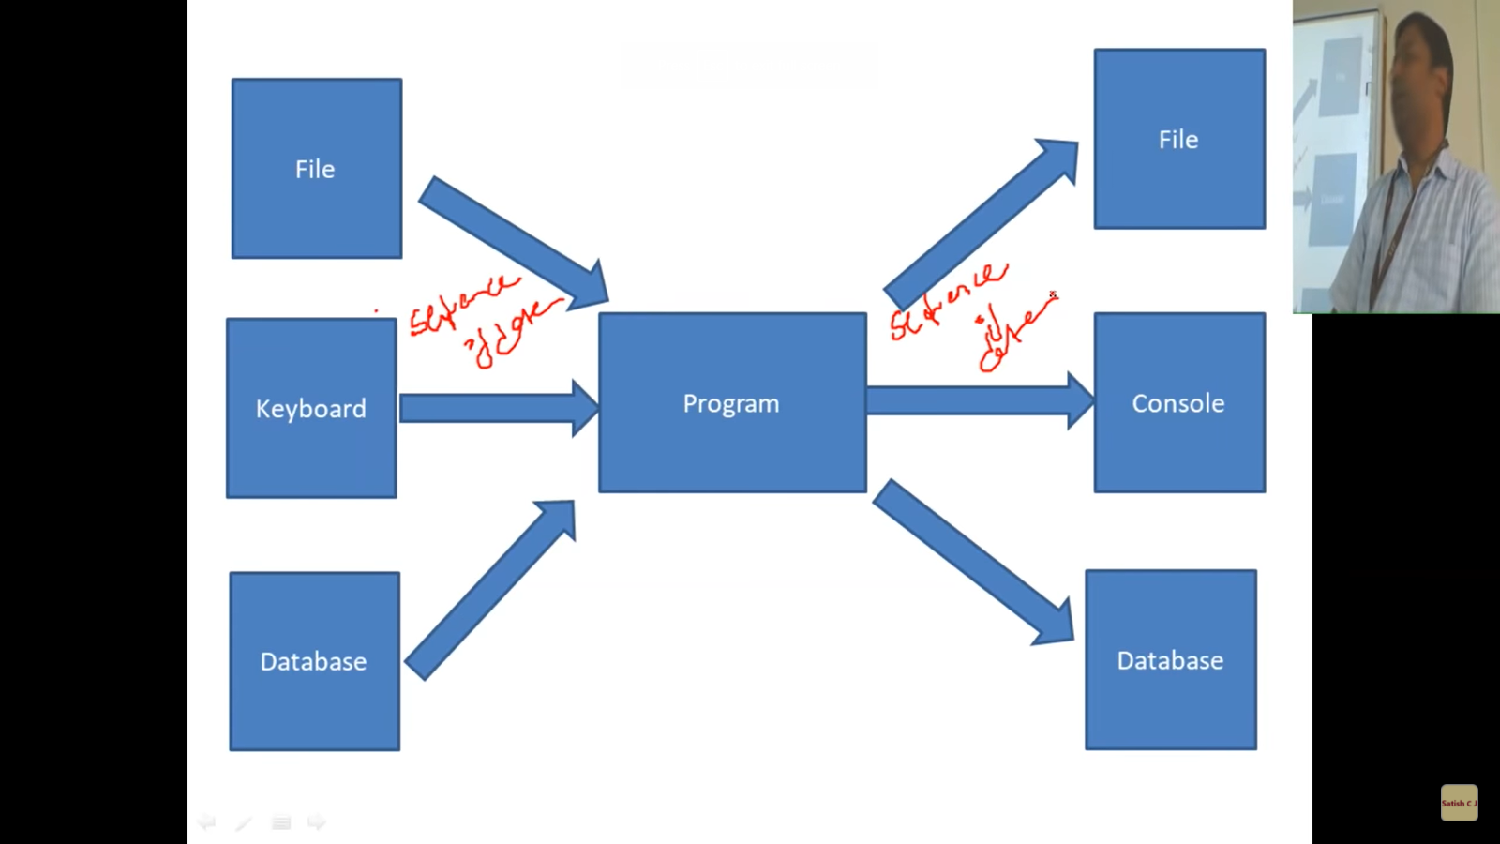

All these are sequence of data.

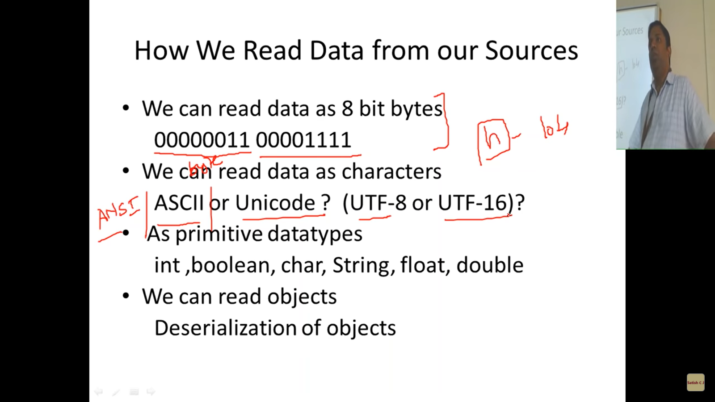

Read data as bytes:

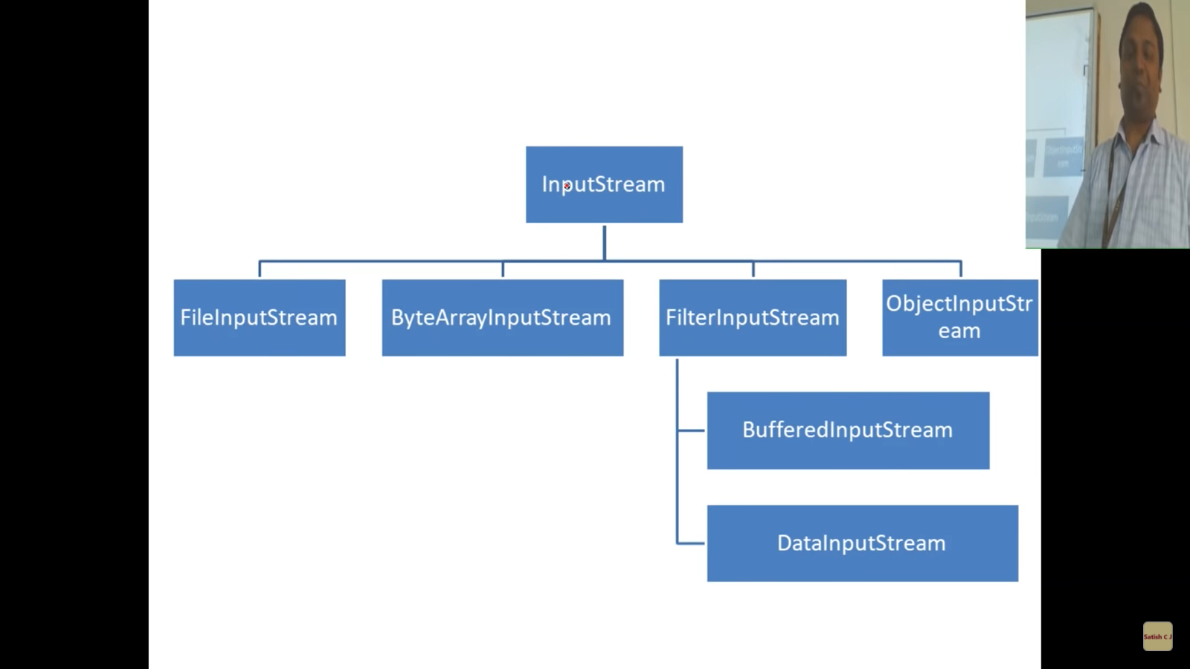

Read data from a file:

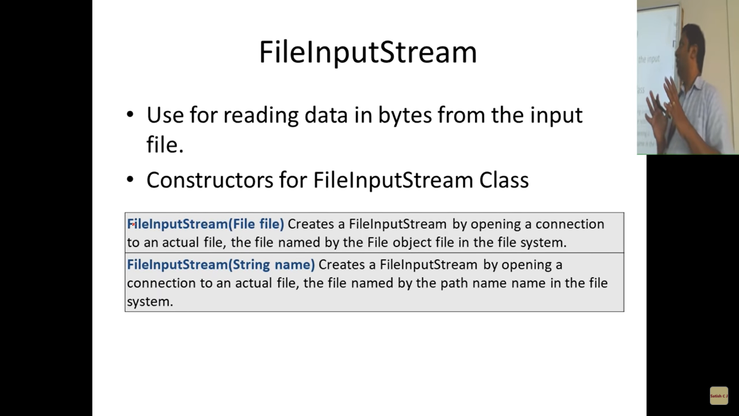

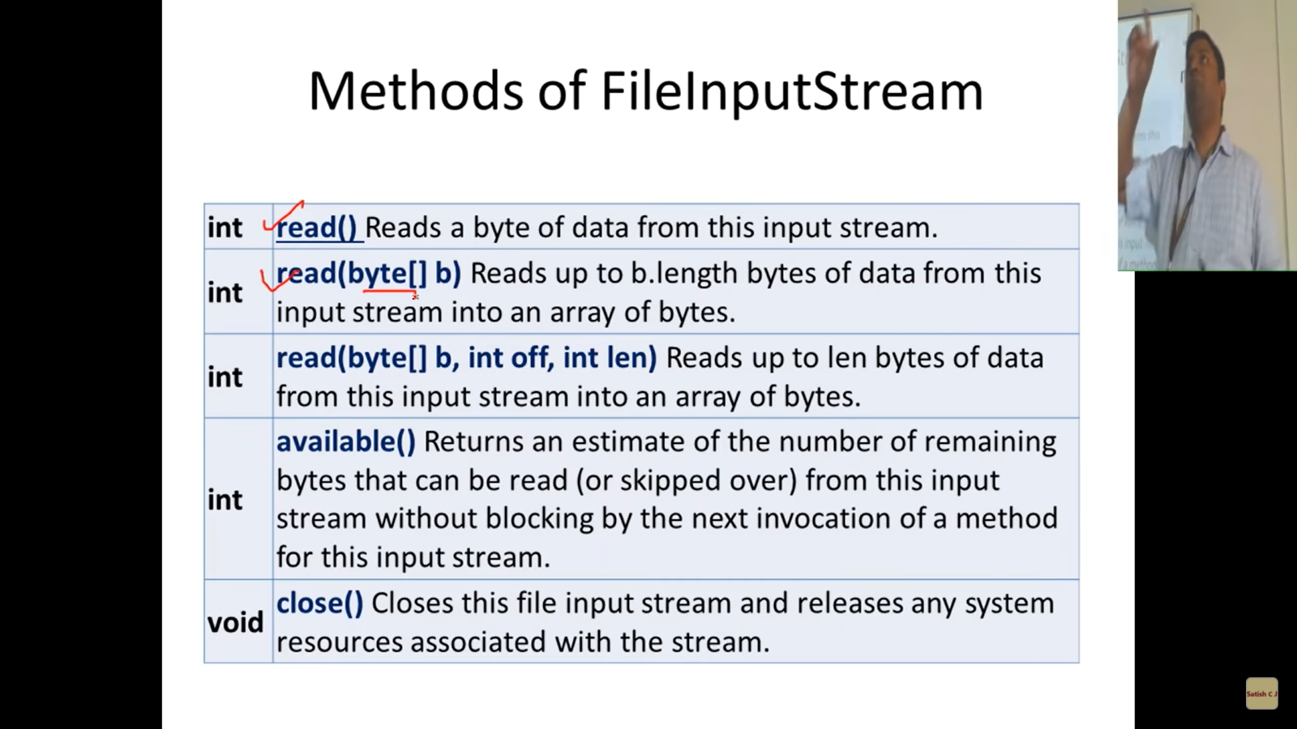

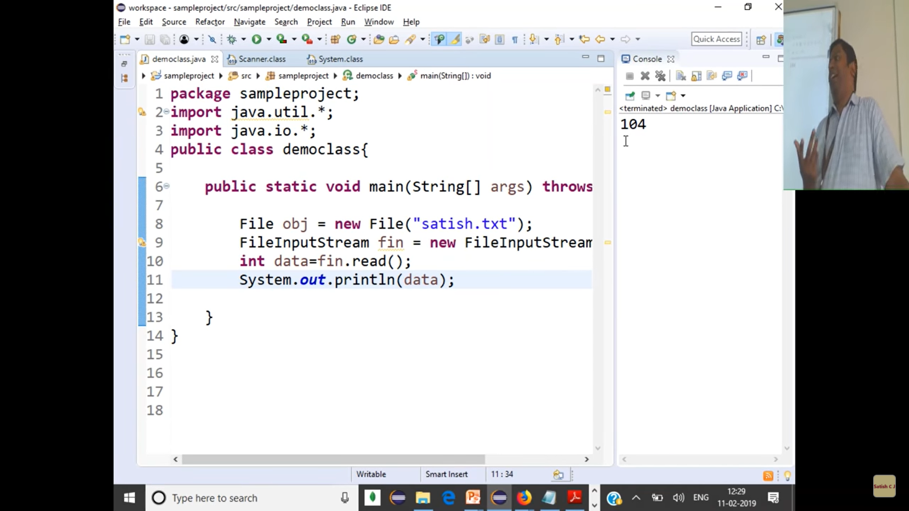

We had “hello” in the file. As we get output as 104, it is the encoded value for ‘h’.

ANSII🡪 ENCODES IN 8 bits

ASCII--🡪 excodes in 7 bits

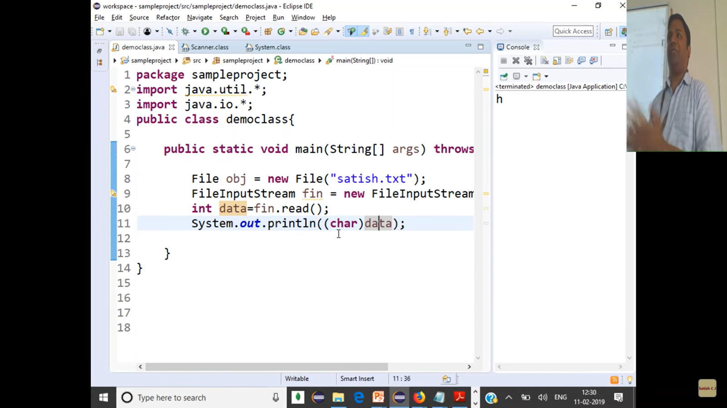

So, we are reading one 8-bit character.